**Set 2 - Assignments on ERD**

Draw an entity relationship diagram for following 4 different scenarios. Specify Entities, Attributes, Relationships when generating ERD.

Note 🡪 It should be a Logical Data Model and not a Conceptual Data Model.

**Question 1:**

Different movies are released on different dates & has information related to movies. It also keeps track of which actors are working in which movies. Each movie has different shows according to day & time. There might be the case that information about a theater is maintained separately. The width of the screen, capacity of seats has already been decided which hosts multiple shows.

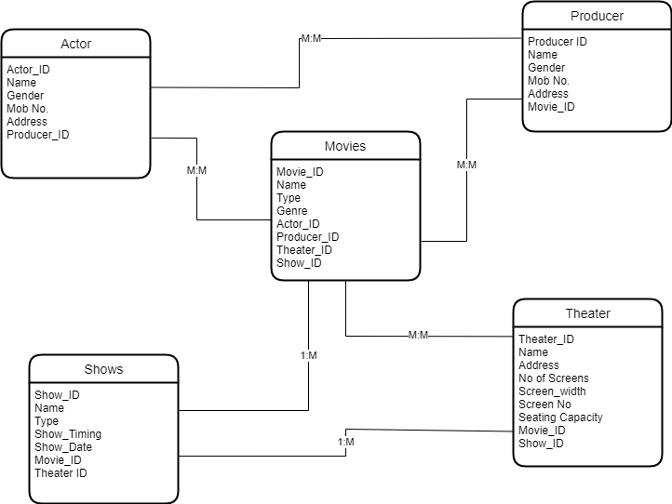

**Question 2:**

A General Hospital consists of a number of specialized wards (such as Maternity, Pediatric, Oncology, etc.). Each ward hosts a number of patients, who were admitted on the recommendation of their own GP and confirmed by a consultant employed by the Hospital. On admission, the personal details of every patient are recorded. A separate register is to be held to store the information of the tests undertaken and the results of a prescribed treatment. A number of tests may be conducted for each patient. Each patient is assigned to one leading consultant but may be examined by another doctor, if required. Doctors are specialists in some branch of medicine and may be leading consultants for a number of patients, not necessarily from the same ward.

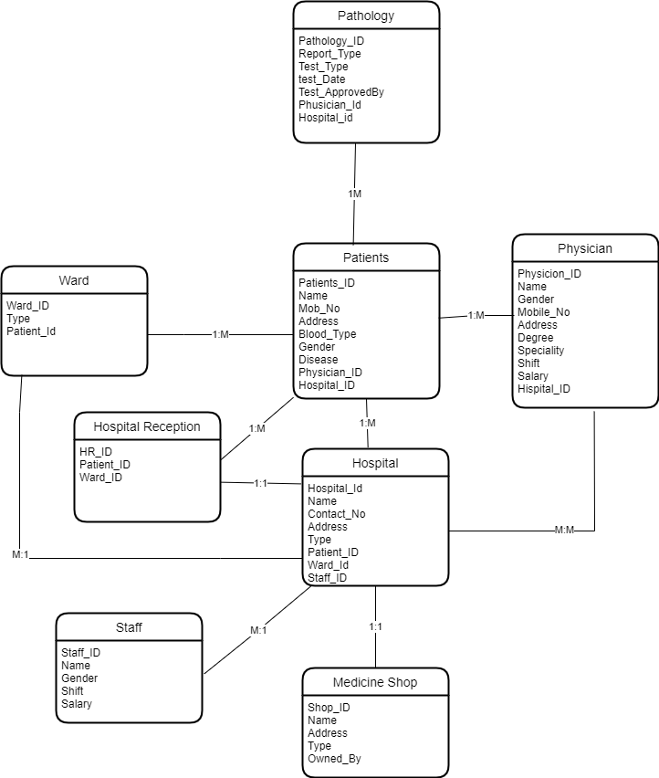

**Question 3:**

A publishing company produces scientific books on various subjects. The books are written by authors who specialize in one particular subject. The company employs editors who, not necessarily being specialists in a particular area, each take sole responsibility for editing one or more publications. A publication covers essentially one of the specialist subjects and is normally written by a single author. When writing a particular book, each author works with on editor, but may submit another work for publication to be supervised by other editors. To improve their competitiveness, the company tries to employ a variety of authors, more than one author being a specialist in a particular subject.

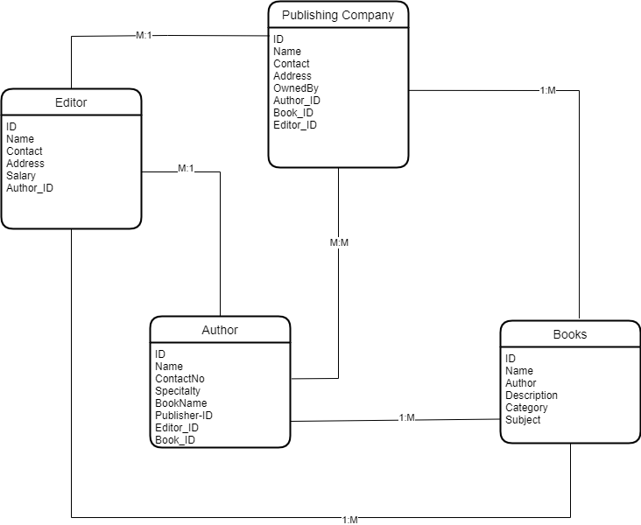

**Question 4:**

Notown Records have decided to store information about musicians who perform on its albums (as well as other company data) in a database. The company has wisely chosen to hire you as a database designer (at your usual consulting fee of $2500/day).

1. Each musician that records at Notown has an SSN, a name, an address and a phone no. Poorly paid musicians often share the same address, and no address has more than one phone.

2. Each instrument used in songs recorded at Notown has a name (e.g. guitar, synthesizer, flute) and a musical key (e.g. C, B-Flat or E-Flat)

3. Each song recorded album recorded on the Notown label has a title, a copyright date, a format (e.g. CD or MC) and an album identifier.

4. Each song recorded at Notown has a title and an author.

